**Hardwired Café Website Overview**

Corey Crooks

Purdue Global

IT177: Website Development

Kathi Nicholson

March 3, 2021

**Description**: Describe your restaurant.

The Hardwired Café is a hang out spot deisned for hanging out that mixes two of the greatest things of the modern day: Personalized coffee, and Online/LAN Gaming. When customers step in the door, they are greeted with the Creative Lounge in front and to the left, and a Gaming Lounge to the right. The Creative Lounge is a space containing seating, and the Coffee bar. In this area, a respectfull and quiet atmosphere is to be upheld and encouraged for customers to enjoy their beverage, and work on any projects they would like to. Through the doors to the right, customers may take their coffee to the Gaming Lounge, complete with consoles and PC’s alike all connected to the internet. This space is meant for people of many backgrounds to come together, and enjoy their time through the common unity of today’s popular games. Since this area is concealed and separated from the Creative Lounge, it is not expected that any sounds will carry into the other lounges, and as such a volume cap should not be implemented in the Gaming Lounge in order to facilitate immersion and engagement, although volume should be kept reasonable so that no customers will be made uncomfortable.

**Purpose:** What is/are the purpose(s) of my Web site?

The Website of my restaurant will serve to engage potential customers, and provide for a positive first impression. It is increadibly important for the website to give an accurate depiction of the services we will provide, as well as the expected atmousphere of both segments of our Café.

**Goals:** What are the goals of my web site?

Engage prospective customers, and incentivize a visit.

Inform customers on what exactly to expect from either side of the Café.

Make it easy for customers to reach out for staff to answer questions.

Provide locational information to help clients reach the Café.

**Audience:** Who is my target audience?

Customers that would like to experience a new take on the Café culture.

Customers that may not have the internet stability or hardware required to experience today’s demanding games.

Customers that are interested in the dualistic nature of the Café, and would like to participate in either or both of those natures.

Customers that would like to be apart of a more relaxed system, and help the Café grow with their needs and interests.

**Color Scheme:** Describe the color scheme you will use on your site.

Due to the opposing natures of both the Creative Lounge and the Gaming Lounge, I would implement a sort of clashing colour scheme, separating the two parts of the restaurant into sections of the website. This will help give clients an accurate depiction of what to expect inside the Café. Due to this, the Creative Lounge portion of the site should use more earth tones. For example the text should be a darker colour such as brown with the background being a lighter cloudy-sky-blue. The navigation bar and headers can pull these concepts together with utilizing a lighter green and soft orange/yellow. The Gaming Lounge sections will be darker, and more vibrant colours. The background should utilize a dark colour such as black or soft dark blue. The text can be a light grey or white to contrast with the background. The navigation bar could be composed of a darker colour similar to the backround, but desitnct enough to distinguish the two.

**Layout:** Which layout will you use?

Layout B:

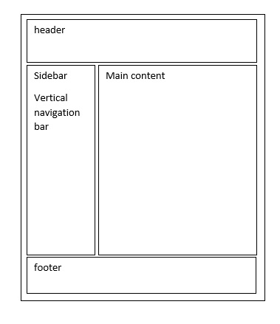

**Content**: Define the content of your website.

Home Page: Introduce the two aspects of the website, and let customers navigate to both sites using intuitive systems and graphics.

About Us Page: Introduce the staff of the restaurant, and give customers context of our mission of unity, and why we feel the need to bring these two cultures together.

Staff Page: This page should short personally written bio’s for each of the workers at both sections of the restaurant.

Café Menu Page: This page will include what drinks are served at the Café as well as the prices for them.

Gaming Menu Page: This page gives customers information on what games are available, as well as announcments for any repairs or down-time the hardware in the Gaming Lounge needs.

Contact Us Page: Here will provide contact information and encourage customers to leave their impressions in order to help the Café adapt and grow to customer interests.

Thank You Page: This page may explain why customer feedback is important, as well as telling the customer why we respect each of them as individuals inorder to help them feel that their experience was valued.

History Page: This page may explain how the idea for the café came to be, and why it has evolved the way it did. Questions answered may be but are not limited to: Why the two sections? Why not specialize in one single setting? What is the point? How does the community come into perspective when making decisions?